# How to run the Home Automation System

1. Download Blynk App on your Mobile device
2. Set your Blynk App according to your project
3. Configure your Sensors with NodeMCU (Settings Available in the coding part)
4. Once your NodeMCU is configured, Download and Install Arduino IDE Software.
5. Open New Project and paste the “Home_automation-System_Program” in the new project or you can directly open “Home_Autonation_System.ino” file from the Home_Automation_System Folder.
6. Once the Program is ready configure your NodeMCU with the Arduino App and upload the program
7. After successful Installation of the Program the project will Start Working

# Configuring NodeMCU with Arduino IDE

## Step 1: ​Installing Arduino IDE Software

Install Arduino IDE software from the link <http://www.arduino.cc/en/main/software>

## Step 2: Arduino IDE Icon

After installing Arduino IDE icon is created on the Desktop as show in the figure

## Step 3: Opening Arduino IDE

[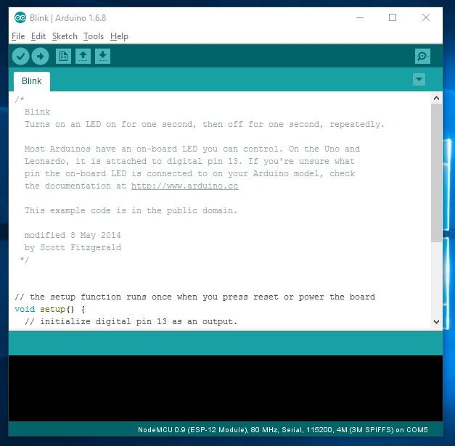](https://cdn.instructables.com/F4S/4P2Y/IMF3TYCB/F4S4P2YIMF3TYCB.LARGE.jpg?auto=webp&fit=bounds)

Click on the Icon to open the Arduino window as shown in the figure

## Step 4: Preferences

[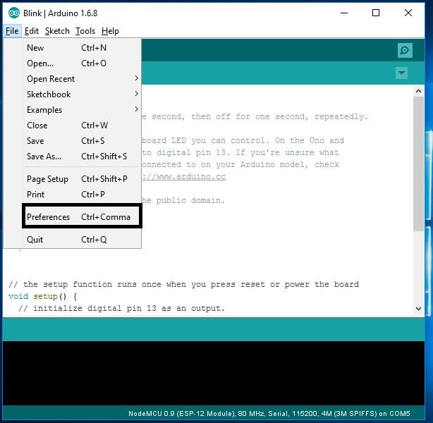](https://cdn.instructables.com/FHP/AKIV/IMF3TYG4/FHPAKIVIMF3TYG4.LARGE.jpg?auto=webp&fit=bounds)

Open the File and click on the Preferences as shown in the figure

## Step 5: Adding ESP8266 Board Manager

[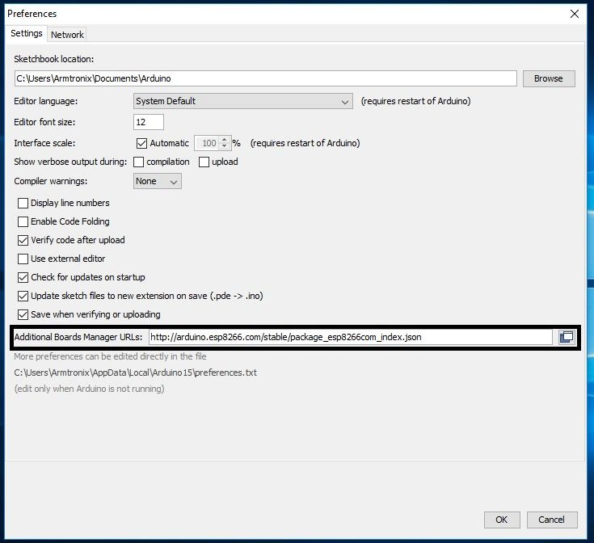](https://cdn.instructables.com/FDV/1WRF/IMF3TZO9/FDV1WRFIMF3TZO9.LARGE.jpg?auto=webp&fit=bounds)

<http://arduino.esp8266.com/stable/package_esp8266com_index.json>

## Step 6: Selecting Board

[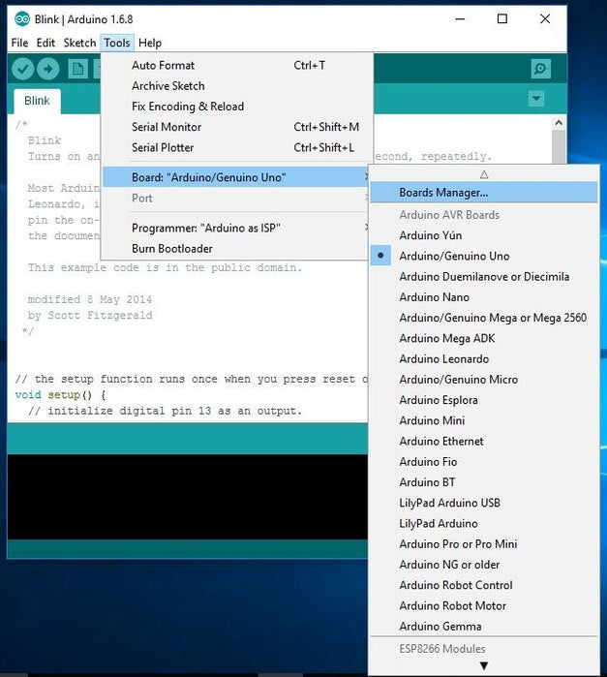](https://cdn.instructables.com/FFS/FWV0/IMF3TZQ3/FFSFWV0IMF3TZQ3.LARGE.jpg?auto=webp&fit=bounds)

Now open the tools in that select **Board: “Arduino/Genuino Uno”**and click on the **Boards Manager** as shown in the figure

## Step 7: ESP8266 Board Package

[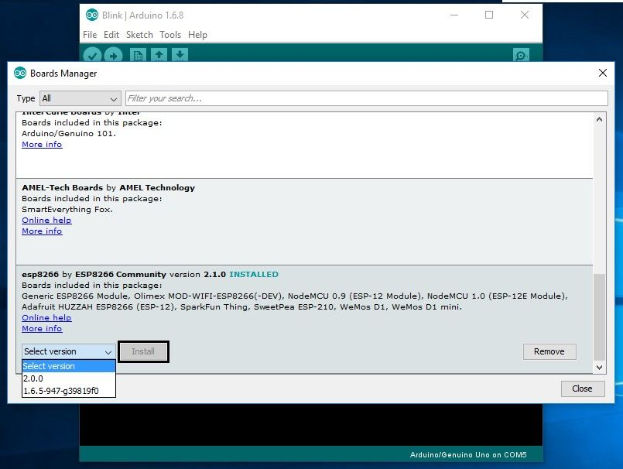](https://cdn.instructables.com/FKP/T36T/IMF3TZVF/FKPT36TIMF3TZVF.LARGE.jpg?auto=webp&fit=bounds)

The Boards Manager window opens, scroll the window page to bottom till you see the module with the name ESP8266. Once we get it, select that module and select version and click on the Install button. When it is installed it shows Installed in the module as shown in the figure and then close the window.

## Step 8: Selecting ESP8266 Arduino Board

[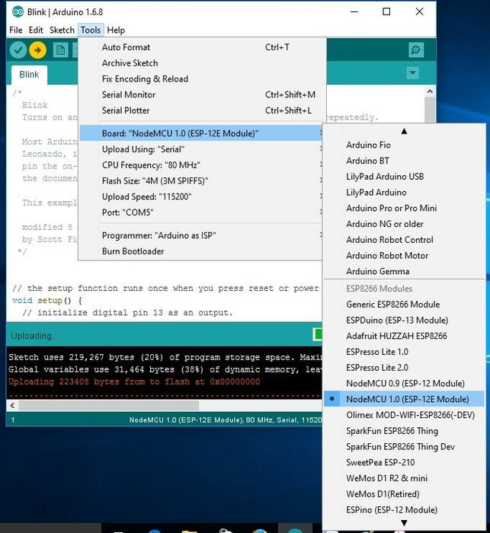](https://cdn.instructables.com/F1F/8PAV/IMF3U001/F1F8PAVIMF3U001.LARGE.jpg?auto=webp&fit=bounds)

To run the esp8266 with Arduino we have to select the **Board: “Arduino/Genuino Uno”** and then change it to **NodeMCU 1.0 (ESP-12E Module)** or other esp8266 modules depending on what you have .This can be done by scrolling down, as shown in the figure

## Step 9: Connecting ESP8266 to the PC

[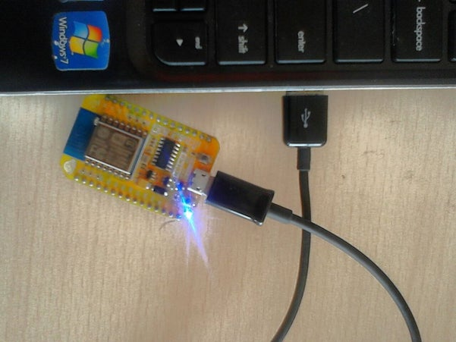](https://cdn.instructables.com/F41/QW7M/IMF3U080/F41QW7MIMF3U080.LARGE.jpg?auto=webp&width=1024&fit=bounds)

[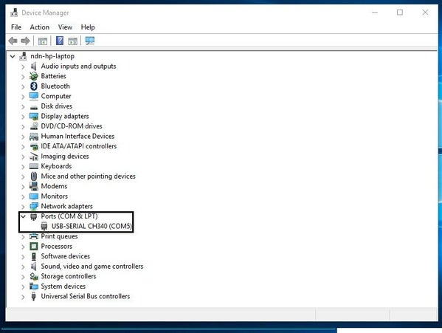](https://cdn.instructables.com/F2D/0LHE/IMF3U07X/F2D0LHEIMF3U07X.LARGE.jpg?auto=webp&fit=bounds)

Now Let’s connect the ESP8266 module to your computer through USB cable as shown in the figure. When module is connected to the USB, COM port is detected eg: here COM5 is shown in the figure.

## Step 10: Selecting Example Program in Arduino IDE

[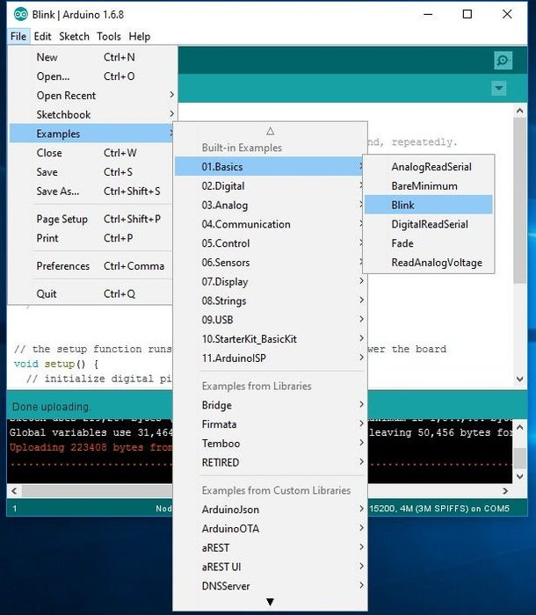](https://cdn.instructables.com/FUU/2F5X/IMF3U0BV/FUU2F5XIMF3U0BV.LARGE.jpg?auto=webp&fit=bounds)

Now open the File tab in that go to the Examples in that enter into Built-in example, go to 01.Basics and click on Blink to open the window

## Step 11: Selecting COM Port

[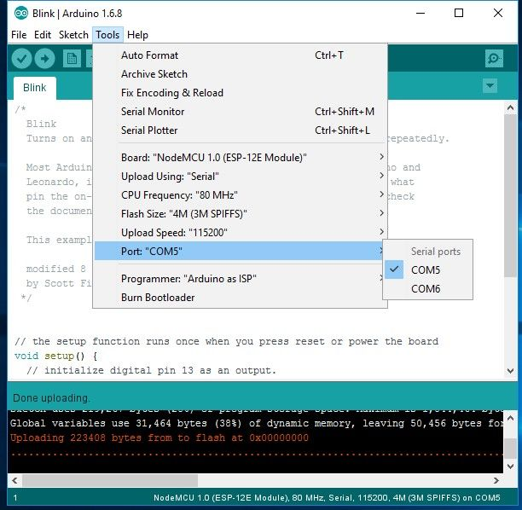](https://cdn.instructables.com/FE5/8PWW/IMF3U0L0/FE58PWWIMF3U0L0.LARGE.jpg?auto=webp&fit=bounds)

The Blink example will open on a new window , click on tools to select the port: “COM” based on which esp8266 module is connected to your respected COM port of the computer. To select COM port refer previous steps.

## Step 13: Adding Libraries

[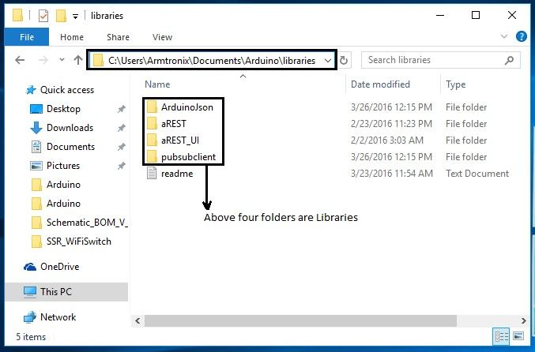](https://cdn.instructables.com/FLY/LSBD/IMF3U11U/FLYLSBDIMF3U11U.LARGE.jpg?auto=webp&fit=bounds)

In case you need to add the libraries to the Arduino follow the example path is shown in the figure i.e C:\Users\Armtronix\Documents\Arduino\libraries. Enter into the libraries folder then paste the file in that as shown below.